Grove City Area C.A.R.E. Living at Home Program
205 3rd Street South – Grove City, MN 56243
www.grovecitycare.com gcacare@embarqmail.com Staff:
320-857-2274 Andrea Dallmann
Program Director
Rosemary Dilley
Volunteer Coordinator
Dear Friends and Neighbors:
The Grove City Area C.A.R.E. Living at Home Program continues to serve the older adults in our community. With your generous support, we have been able to provide a variety of services designed to help older adults stay in their homes.
The Care Program serves people 65 and older in Grove City to Mannanah to Cosmos, and the surrounding rural areas as well. We provide meals on wheels, transportation, nursing and home health aide services, companionship, handicap equipment, support groups, and other services such as lifeline, vision loss, and hearing loss resources.
As awareness of the program grows and the population ages, the need for services increase. Older adults are aging with dignity and independence, and are valuable contributors to society. 2030 marks the year the baby boomers begin to turn 85. Now is the time for communities to begin a new conversation about what our future can be so all older adults and their families are supported and communities can thrive.
Where will we be at 2030?
Around 2020, MN's age 65+ population is expected to surpass the 5-17 school-age population for the first time…Sometime over the next year, there will be more older Minnesotans (65+) than school-aged kids (5-17). Moreover, while our school-aged population is projected to remain largely level over the coming decades, the number of older adults will continue to grow. For more information on 2030 see: https://www.mncompass.org/aging/overview:
Navigating through Grief Support Group
Join us every last Monday of the month at 2:00 pm ~ Trinity Lutheran Church, 54384 Highway 12,
Grove City, MN 56243 - Light refreshments will be served
You do not have to be a member of Trinity Lutheran Church to attend our support group. There is no charge to participate. Feel free to bring a friend.
Questions? Contact Erin Riebe, Family Service Coordinator at Johnson-Hagglund Funeral & Cremation Service by calling 693-8151, or Grove City Care at 857-2274.
==================================================================================================
Custom Processing
Frozen Meat Sales
USDA Inspected Est.
Homemade sausages-
(beef, pork, & buffalo)
Charles Carlson
Since 1913 105 N. 2nd St. Grove City, MN

Care Board Members: Donations from March 2019 – August 2019:

Linda Mickelson – President In memory of Lucille Sundahl
Steve Schmidt – Co-Chair by Diane Malmin, Jerry/Joan Reckdahl, Ardy Johnson, County Commissioner Janice Malmquist, Lucille Pautzke, Ardy Thorpe,
Becky Vann – Secretary Donna Rueckert, Brad Bird/Sharon Smith, Charlotte
Barb Lambertson – Treasurer Liedholm, Arlene Johnson,
Donna Hedtke
Bill Peterka – Grove City Council member In memory of Muriel Nelson by Carol Nelson
Ardy Johnson In memory of Butch Weseman by Dale Pautzke
Dennis Brown In memory of Doug Torgelson by Don/Linda Mickelson,
Thank you for your time and dedication to the Arlene Johnson, Ardis Thorpe, Ardy Johnson, Lucille
Care Program! Pautzke,
In memory of Gale Peterson by Charlotte Liedholm,
Linda Mickelson, Ardis Thorpe, Ardy Johnson
In memory of Fred Borchert by Arlene Johnson.
If you or someone you know would like to be a volunteer please come to the Care Office and we can talk about what we do!
Volunteers are the back bone to this program!
Here are our volunteers of the month:
In memory of Fred Borchert, Donald Holmgren, Dean Cordes, and James Jensen by Gordon/Jane Czycalla, In memory of Dean Cordes by Don/Linda Mickelson, and Debra Anderson Bergstrom

Care Volunteers of the Month:
March: Bob & Ruth Cordes July: Andi Michalski &
April: Ardy Johnson Dorinda Rassler
May: Charlotte Liedholm August: Marlys Larson
June: Bob & Ruth Cordes

Special thanks go to those who helped make
handicap doors possible on the west side of
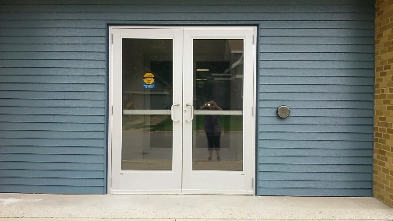
South Grove
Donations: * Grove City Care Program
Danielson United Fund
Dean Stenberg
Trinity Lutheran Church
SW MN Synod Spring Gathering * VFW Gambling
Lucille Pautzke
Swede Grove Fund Drive * Bernick’s
Litchfield American Legion – No. 104
Carol Struthers
Lois Rouser
Wintercade of Litchfield
Jo Celander – 3M Volunteer match *Meeker County Commissioners
Melissa Casey *City of Grove City

Special thanks to our Ad Sponsors for your Continued support!

To help with our nursing services and
transportation we are partnered with:
Thank you for all you do!
www.201buildingsupply.com
201 Pacific Ave / Grove City, MN 56243
Phone: 320-857-2031 / Fax: 320-857-2033

===============================================

Don’t forget the bus runs through Grove City.

=============================================

=================================================================================================
I am now a trained community partner for the Aging Eyes Initiative. The initiative provides training and a kit of low vision aids and devices to community members who work with seniors. These community partners can then provide practical assistance to seniors in the early stages of vision loss. If you would like more information or simply want to see what is available please come to the Care Office and we can visit – Andrea

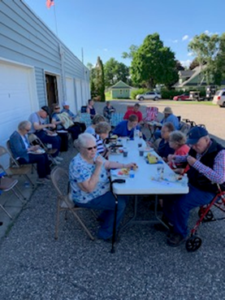
of Grove City
320-857-2741
snacks *gas * pop *pizza *subs *coffee
Make Schmidty’s Your First Stop!
================================
So much fun at Bonfire Night! Thank you to everyone who helped make this a great night.
We now look forward to flower tours, Carlson Apple Orchard, Octoberfest, and Christmas Shopping. Who knows what else will pop up!

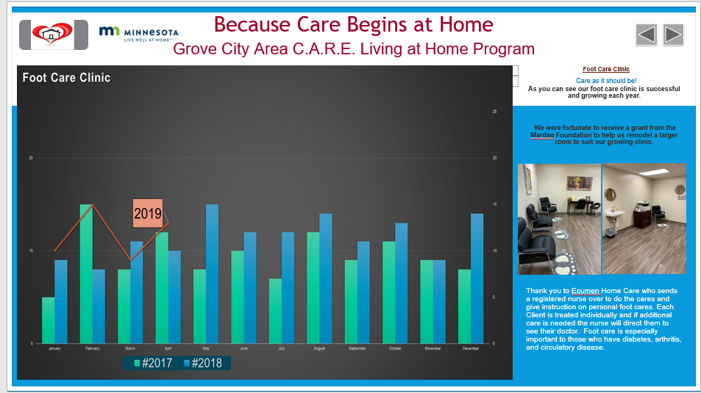

This is just one of the three pages that were displayed at the Duluth DHS Conference this year for the Care Program. We were asked to display an eposter this year instead of the original board poster. It was a challenge but very exciting to see Grove City displayed on a T.V. at such a large conference of 1800 people. If you would like to see the rest please feel free to stop in the office
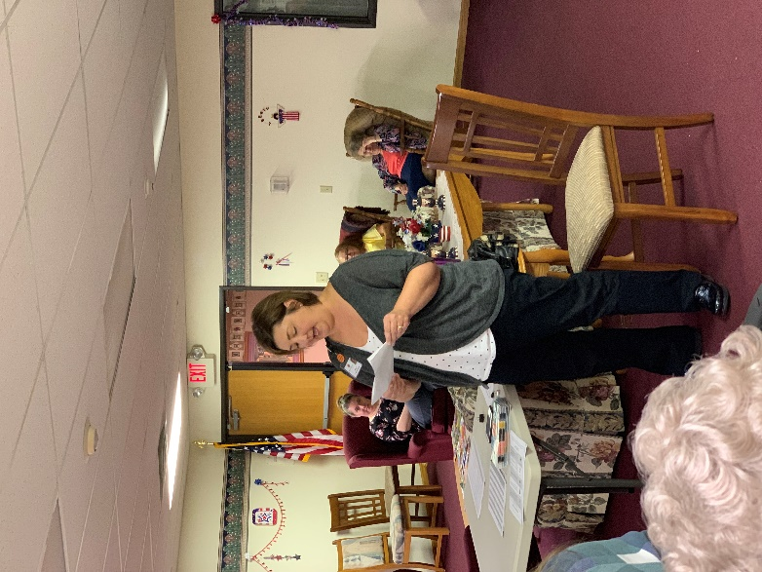
The first day of fall marks Falls Prevention Awareness Day — and this year we had the opportunity for people to learn how to prevent
fall-related injuries that affect older adults with Amy, from MMH Physical Therapy Dept.
Unfortunately, every 11 seconds an older adult is hospitalized for a fall; every 19 minutes an older adult dies from a fall. These numbers are scary,
but many accidents can be prevented. So, this year, get involved with your community — local, state and national — and spread the message of prevention.

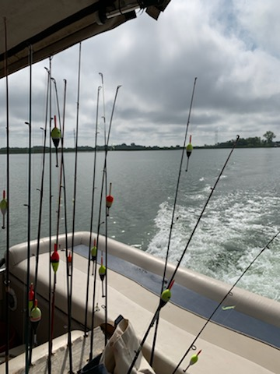

Over 100 years of Service Let’s Go Fishing!

Thank you for another
Glorious day!
110 Atlantic Avenue West
Grove City, MN 56243
320-857-2521

Why I attend Bone Builders: I come to bone builders
because it is good for your body and good to be with other people!
Why I volunteer: After retirement and your family is all grown
up; you need something to make you feel useful again.
Volunteering is a good way to do this. You also need to
do something beneficial for yourself. Joining Bone
Builders exercise program makes you feel great! It is a
BONE BUILDERS IS PICKING UP THE PACE! – low-key exercise, but it strengthens muscles and bones
Come join our group and feel better every day – And it is lots of fun!! – Carol Nelson You deserve to feel good and be active!
Every Monday and Thursday
10am to 10:45am
South Grove Cardinal room
off of the gym at West doors.

